**Assignment 2**

* 1. Write a Python Program to implement your own myreduce() function which works exactly like Python's built-in function reduce()

**Solution:**

def reducefun(funct, seq):

result = seq[0]

for i in seq[1:]:

result= funct(result,i)

return result

def multiplication(x,y): return x*y

print("My reduce function:", reducefun(multiplication,[1,2,3,4]))

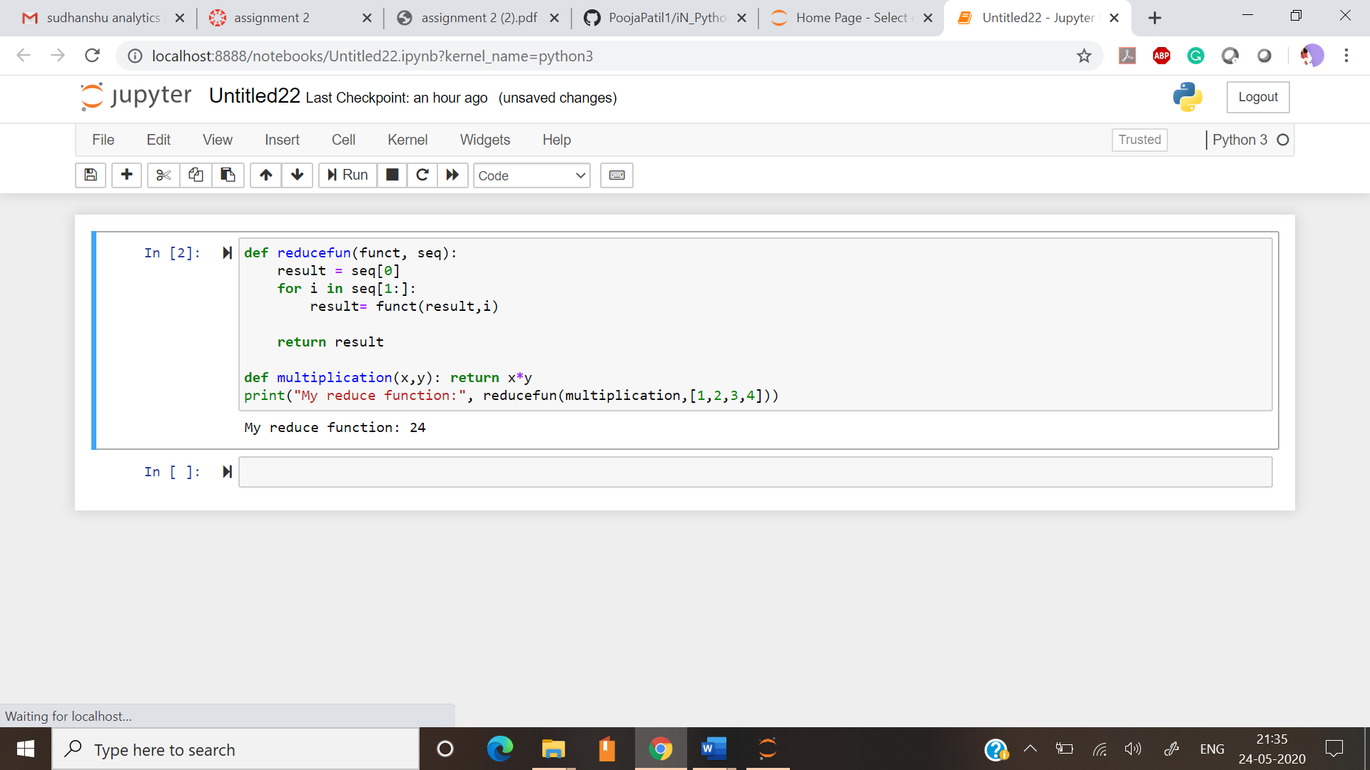

* 1. Write a Python program to implement your own myfilter() function which works exactly like Python's built-in function filter()

**Solution:**

def filterfun(funct,seq):

result = []

for i in seq:

if funct(i):

result.append(i)

return result

def funct(i):

if i%2 == 0:

return True

else:

return False

print("Even numbers in series are:", filterfun(funct,[1,2,3,4,5,6,7]))

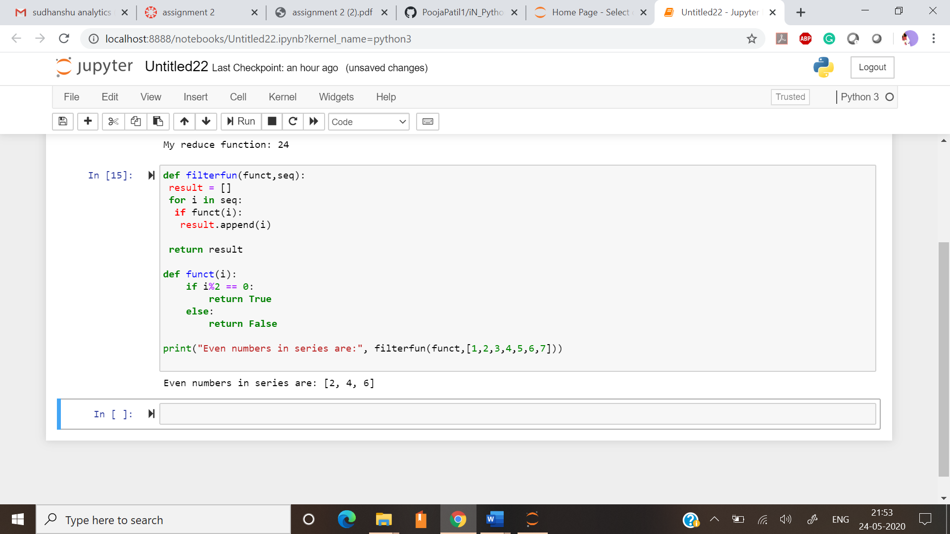

2. Implement List comprehensions to produce the following lists. Write List comprehensions to produce the following Lists ['A', 'C', 'A', 'D', 'G', 'I', ’L’, ‘ D’] ['x', 'xx', 'xxx', 'xxxx', 'y', 'yy', 'yyy', 'yyyy', 'z', 'zz', 'zzz', 'zzzz'] ['x', 'y', 'z', 'xx', 'yy', 'zz', 'xx', 'yy', 'zz', 'xxxx', 'yyyy', 'zzzz'] [[2], [3], [4], [3], [4], [5], [4], [5], [6]] [[2, 3, 4, 5], [3, 4, 5, 6], [4, 5, 6, 7], [5, 6, 7, 8]] [(1, 1), (2, 1), (3, 1), (1, 2), (2, 2), (3, 2), (1, 3), (2, 3), (3, 3)]

**Solution:**

string = "ACADGILD"

string_list = [ alphabet for alphabet in string]

print ("ACADGILD => " + str(string_list))

ip_1 = ['x','y','z']

result = [ item*num for item in ip_1 for num in range(1,5) ]

print("['x','y','z'] => " + str(result))

ip_2 = ['x','y','z']

result = [ item*num for num in range(1,5) for item in ip_2 ]

print("['x','y','z'] => " + str(result))

ip_3 = [2,3,4]

result = [ [item+num] for item in ip_3 for num in range(0,3)]

print("[2,3,4] =>" + str(result))

ip_4 = [2,3,4,5]

result = [ [item+num for item in ip_4] for num in range(0,4) ]

print("[2,3,4,5] =>" + str(result))

ip_5=[1,2,3]

input_list=[1,2,3]

result = [ (b,a) for a in ip_5 for b in input_list]

print("[1,2,3] =>" + str(result))

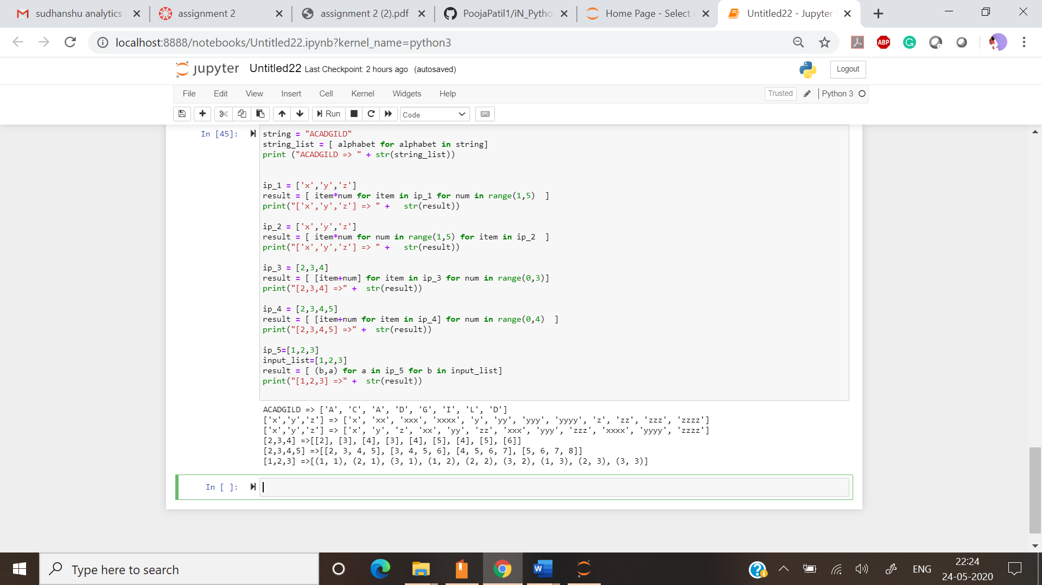

3. Implement a function longestWord() that takes a list of words and returns the longest one

**Solution:**

def get_longest_word(w_list):

word_len = []

for n in w_list:

word_len.append((len(n), n))

word_len.sort()

return word_len[-1][1]

print(get_longest_word(["Pooja", "Patil", "ComputerCSE"]))

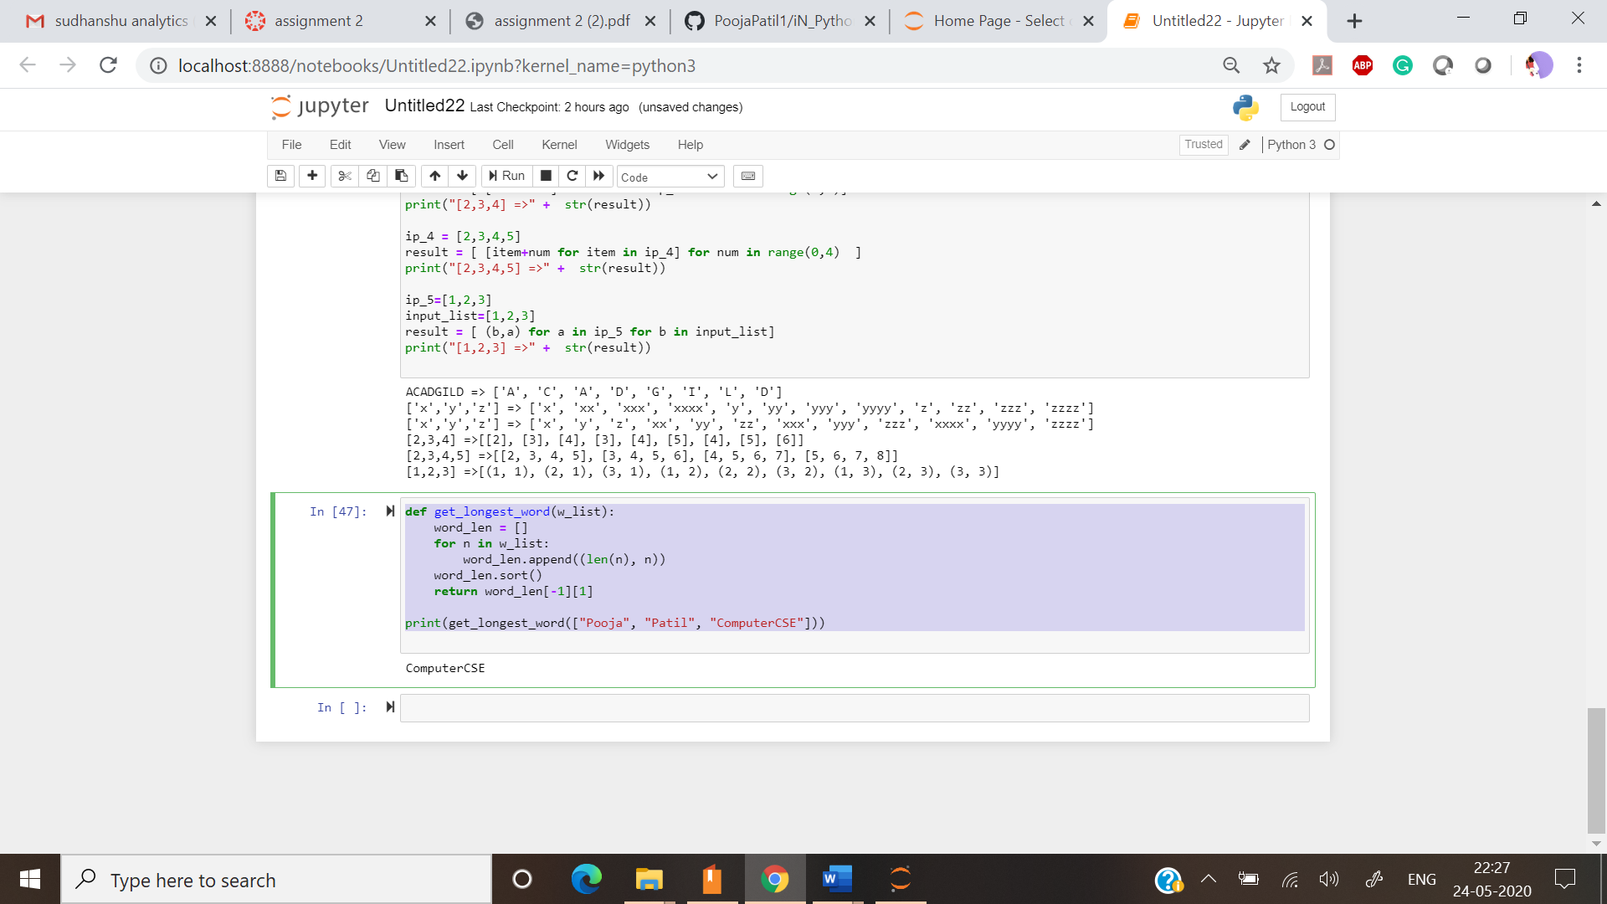

Task 2:

* 1. Write a Python Program(with class concepts) to find the area of the triangle using the below formula. area = (s*(s-a)*(s-b)*(s-c)) ** 0.5 Function to take the length of the sides of triangle from user should be defined in the parent class and function to calculate the area should be defined in subclass.

Solution:

class Triangle:

def __init__(user,a,b,c):

user.a = float(a)

user.b = float(b)

user.c = float(c)

def area(user):

s=(user.a + user.b + user.c)/2

return((s*(s-user.a)*(s-user.b)*(s-user.c))**0.5)

a=input("Enter the value of a = ")

b=input("Enter the value of b = ")

c=input("Enter the value of c = ")

t = Triangle(a, b, c)

print("area : {}".format(t.area()))

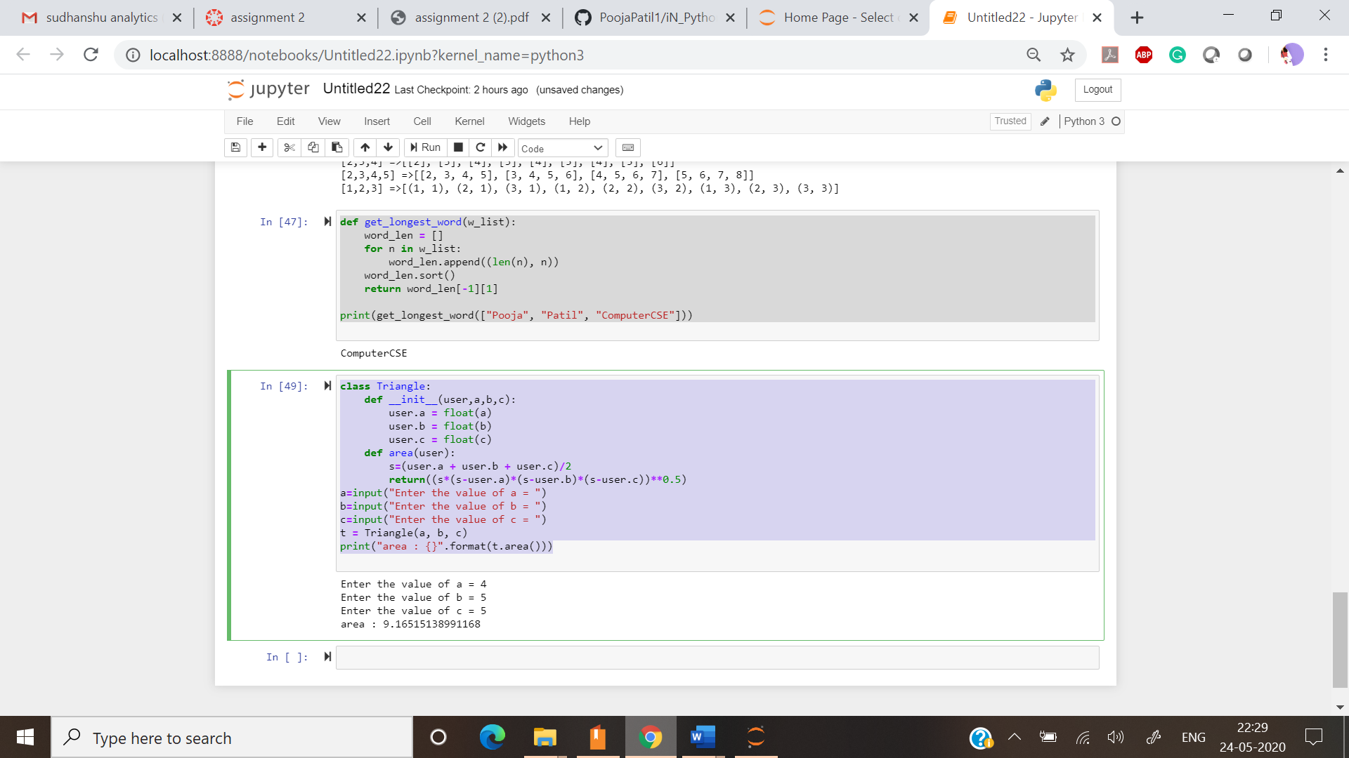

* 1. Write a function filter_long_words() that takes a list of words and an integer n and returns the list of words that are longer than n.

Solution:

def filter_long_words(l,a):

words=[]

for j in l:

if(len(j)>=a):

words.append(j)

return words

n=input("Enter words:")

nt=n.split(",")

na=input("Enter Min Length:")

long=filter_long_words(nt,int(na))

print("Words with at least min length:",long)

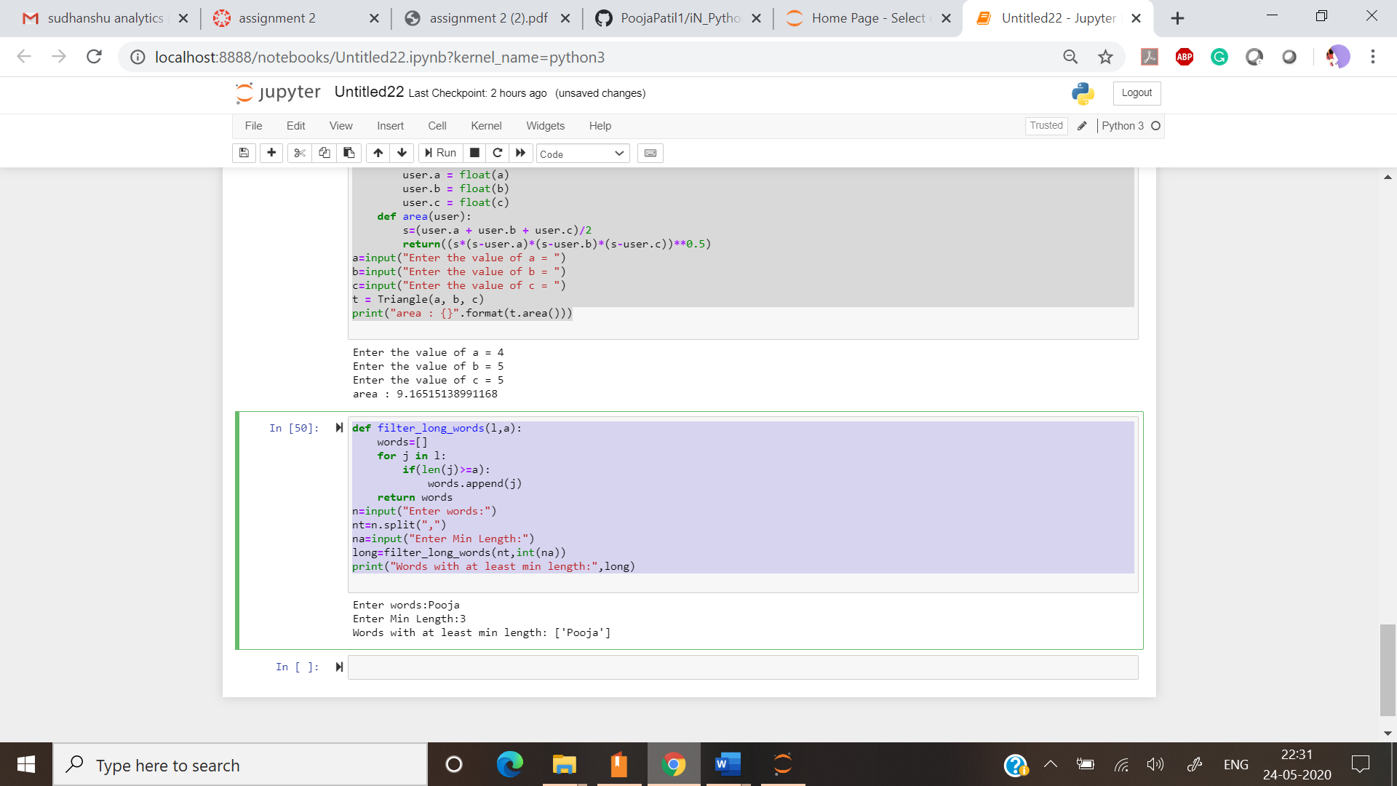

2.1 Write a Python program using function concept that maps list of words into a list of integers representing the lengths of the corresponding words.

**Solution:**

wordlist = ["aaab","cdssse","ertay"]

def wordlength(wordlist):

return list(map(lambda x: len(x), wordlist))

print ("word lengths in array => " + str(wordlength(wordlist)))

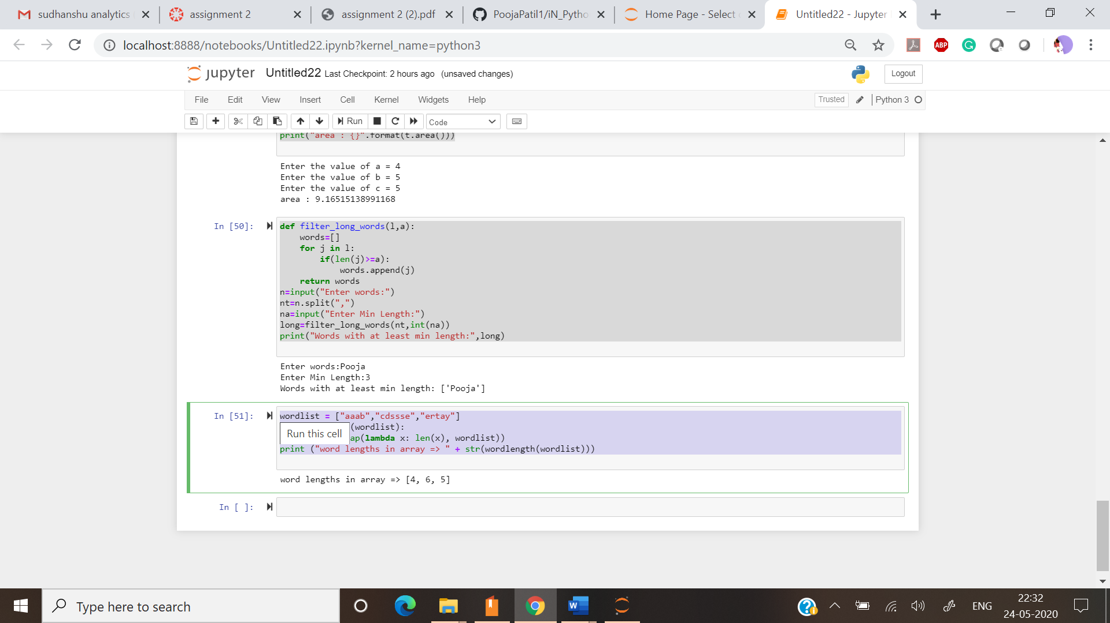

2.2 Write a Python function which takes a character (i.e. a string of length 1) and returns True if it is a vowel, False otherwise

Solution:

def is_vowel(char):

all_vowels = 'aeiou'

return char in all_vowels

print(is_vowel('P'))

print(is_vowel('o'))

print(is_vowel('j'))

print(is_vowel('a'))

